OPERATION TIME

. metan nTreat meanTreat sdTreat nCont meanCont sdCont, random label(namevar=Author,yearvar=year) texts(150) group1(middle) group2(standard) xlabel(-2.5,0,2.5,5,7.5) boxsca(150) nowt

Study | SMD [95% Conf. Interval]
---------------------+---------------------------------
Yamaguchi et al (200 | 5.006 3.848 6.164
Schibata et al (2003 | 4.341 2.512 6.170
Balzano et al (2003) | -0.311 -0.865 0.242
Su et al (2004) | 7.170 4.312 10.028
Muller et al (2006) | 0.430 -0.014 0.873
Crippa et al (2007) | 0.341 -0.013 0.695
Ocuin et al (2008) | 0.949 0.195 1.703
Shikano et al (2009) | 0.572 0.054 1.090
Lee et al (2010) | 0.185 -0.365 0.734
---------------------+---------------------------------
D+L pooled SMD | 1.497 0.702 2.292
---------------------+---------------------------------

Heterogeneity chi-squared = 107.67 (d.f. = 8) p = 0.000
I-squared (variation in SMD attributable to heterogeneity) = 92.6%
Estimate of between-study variance Tau-squared = 1.2125

Test of SMD=0 : z= 3.69 p = 0.000
OPERATION TIME – CHECKING SMALL SERIES BIAS

. metan nTreat meanTreat sdTreat nCont meanCont sdCont,random
* (to create _ES _seES)

. metabias _ES _seES,graph egger symbol(Oid)
Note: default data input format (theta, se_theta) assumed.
Tests for Publication Bias

Begg's Test
adj. Kendall's Score (P-Q) = 18
Std. Dev. of Score = 9.59
Number of Studies = 9
z = 1.88
Pr > |z| = 0.061
z = 1.77 (continuity corrected)
Pr > |z| = 0.076 (continuity corrected)

Egger's test
------------------------------------------------------------------------------
Std_Eff | Coef. Std. Err. t P>|t| [95% Conf. Interval]
-------------+----------------------------------------------------------------
slope | -1.122745 .4992492 -2.25 0.059 -2.303282 .0577916
bias | 6.246201 1.672567 3.73 0.007 2.291209 10.20119
------------------------------------------------------------------------------

. metafunnel _ES _seES
note: default data input format (theta, se_theta) assumed

. metafunnel _ES _seES,egger
ENDOCRINE FAILURE
. metan eventTreat noevTreat eventCont noevCont, fixed label (namevar=Author,yearvar=year) texts(150) group1 (middle) group2(standard) xlabel(.33,1,9) boxsca(150) nowt

Study | RR [95% Conf. Interval]
---------------------+---------------------------------------------------
Yamaguchi et al (200 | 0.855 0.223 3.274
Balzano et al (2003) | 0.656 0.146 2.949
Shibata et al (2004) | 0.104 0.006 1.743
Muller et al (2006) | 0.043 0.003 0.710
Crippa et al (2007) | 0.150 0.051 0.440
Ocuin et al (2008) | 0.138 0.020 0.952
Cataldegirmen et al | 0.125 0.016 0.947
Hirono et al (2009) | 0.206 0.027 1.583
Shikano et al (2009) | 0.103 0.006 1.743
Di Norcia et al (201 | 0.304 0.144 0.644
Lee et al (2010) | 0.291 0.018 4.609
---------------------+---------------------------------------------------
M-H pooled RR | 0.224 0.144 0.349
---------------------+---------------------------------------------------

Heterogeneity chi-squared = 9.46 (d.f. = 10) p = 0.489
I-squared (variation in RR attributable to heterogeneity) = 0.0%

Test of RR=1 : z= 6.63 p = 0.000
EXOCRINE FAILURE

. metan eventTreat noevTreat eventCont noevCont, random label(namevar=Author,yearvar=year) texts(150) group1(middle) group2(standard) xlabel(.33,1,9) boxsca(150) nowt

Study | RR [95% Conf. Interval]
---------------------+---------------------------------------------------
Yamaguchi et al (200 | 1.016 0.721 1.433
Muller et al (2006) | 1.125 0.675 1.876
Crippa et al (2007) | 0.321 0.108 0.958
Ocuin et al (2008) | 0.346 0.044 2.749
Cataldegirmen et al | 0.333 0.098 1.129
Hirono et al (2009) | 0.186 0.048 0.716
Shikano et al (2009) | 1.346 0.088 20.537
Shibata et al (2004) | (Excluded)
Di Norcia et al (201 | (Excluded)
Lee et al (2010) | (Excluded)
---------------------+---------------------------------------------------
D+L pooled RR | 0.587 0.321 1.071
---------------------+---------------------------------------------------

Heterogeneity chi-squared = 17.12 (d.f. = 6) p = 0.009
I-squared (variation in RR attributable to heterogeneity) = 65.0%
Estimate of between-study variance Tau-squared = 0.3307

Test of RR=1 : z= 1.74 p = 0.082

META-ANALYSIS WITH SUBGROUPS

metan EventCntrl NoEventCntrl EventTrea NoEventTrea , fixed label(namevar=Author,yearvar=Year) texts(160) counts group1(no_drain) group2(drainage) xlabel(.11,.33,1,6,40) boxsca(150) title(MORBIDITY) favours (no drain favoured # drainage favoured) by( studyType)
Study | RR [95% Conf. Interval] % Weight
---------------------+---------------------------------------------------
Cohort
Kumar (2007) | 0.897 0.424 1.899 9.19
Dann (2015) | 0.899 0.707 1.145 57.22
Hirahara (2015) | 0.974 0.496 1.915 9.42
Ishikawa (2011) | 1.818 0.193 17.122 0.83
Sub-total |
M-H pooled RR | 0.918 0.738 1.144 76.66
---------------------+---------------------------------------------------
RCT
Alvarez (2005) | 0.255 0.079 0.824 9.04
Kim (2004) | 0.512 0.201 1.301 9.43
Jiang (2008) | 0.801 0.261 2.454 4.87
Sub-total |
M-H pooled RR | 0.473 0.260 0.859 23.34
---------------------+---------------------------------------------------
Overall |
M-H pooled RR | 0.814 0.662 1.002 100.00
---------------------+---------------------------------------------------

Test(s) of heterogeneity:
Heterogeneity degrees of
statistic freedom P I-squared**
Cohort 0.42 3 0.937 0.0%
RCT 1.94 2 0.379 0.0%
Overall 6.20 6 0.401 3.2%
** I-squared: the variation in RR attributable to heterogeneity)

Note: between group heterogeneity not calculated;
only valid with inverse variance method

Significance test(s) of RR=1
Cohort z= 0.76 p = 0.447
RCT z= 2.46 p = 0.014
Overall z= 1.94 p = 0.053

QUALE GRAFICO E’ MEGLIO ?
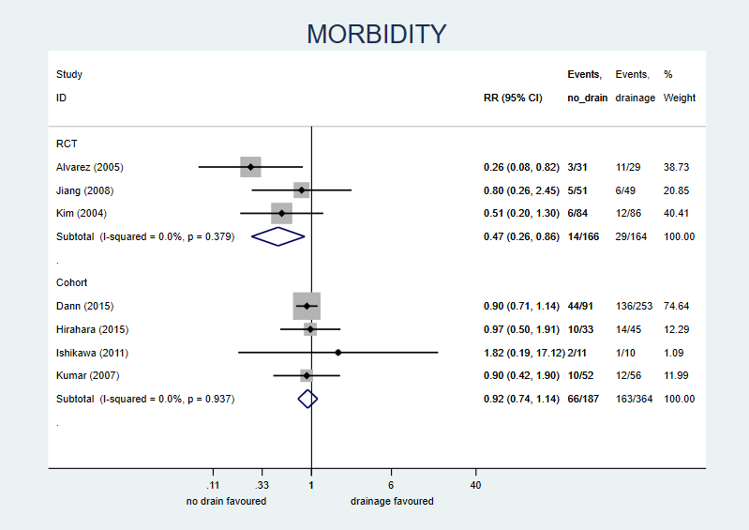
META-ANALISI DEI TEST DIAGNOSTICI (CURVE ROC)
PREDIRE LA TROMBOSI DELLE FISTOLE ARTERO-VENOSE SULLA BASE DEL FLUSSO

Tessitore N, Bedogna V, Verlato G, Moretti F, Poli A. Hemodynamic and clinical monitoring. In Castelli P, Setacci C (eds) Vascular accesses for hemodialysis. Edizioni Minerva Medica, Torino, Italy, 2018

. metandi TP FP FN TN,plot
True positives: TP False positives: FP
False negatives: FN True negatives: TN

Refining starting values:
Iteration 0: log likelihood = -36.56284
Iteration 1: log likelihood = -36.546063
Iteration 2: log likelihood = -36.545057
Iteration 3: log likelihood = -36.55278

Performing gradient-based optimization:
Iteration 0: log likelihood = -36.55278
Iteration 1: log likelihood = -36.531214
Iteration 2: log likelihood = -36.53038
Iteration 3: log likelihood = -36.53038

Meta-analysis of diagnostic accuracy
Log likelihood = -36.53038 Number of studies = 5
---------------------------------------------------------------------
| Coef. Std. Err. z P>|z| [95% Conf.Interval]
-------------+-------------------------------------------------------
Bivariate |
E(logitSe) | .2530628 .6367828 -.9950086 1.501134
E(logitSp) | 1.256385 .263485 .7399643 1.772807
Var(logitSe) | 1.655377 1.39207 .3184847 8.604092
Var(logitSp) | .2262995 .2100555 .0366929 1.395678
Corr(logits) |-.4318786 .4898778 -.9278203 .6157221
-------------+-------------------------------------------------------
HSROC |
Lambda | 2.220096 .7059325 .8364936 3.603698
Theta |-.9561705 .4158251 -1.771173 -.1411682
beta |-.9949623 .5946322 -1.67 0.094 -2.16042 .1704955
s2alpha | .6954426 .6844969 .1010316 4.787023
s2theta | .438194 .3476398 .0925483 2.074744
-------------+-------------------------------------------------------
Summary pt. |
Se | .5629302 .1566739 .2699239 .8177436
Sp | .7784033 .045449 .6769881 .8548063
DOR | 4.524234 2.767835 1.363946 15.00697
LR+ | 2.540336 .7418741 1.433205 4.502712
LR- | .5614953 .1939812 .2852853 1.105129
1/LR- | 1.780959 .6152723 .9048719 3.505263
---------------------------------------------------------------------
Covariance between estimates of E(logitSe) & E(logitSp) -.0503211

Differenza tra la regione al 95% di confidenza e di previsione
